**Question 1:** Event viewer.

**Answer:** The only error I was able to find in the event viewer was one with a 404 id (see image below).

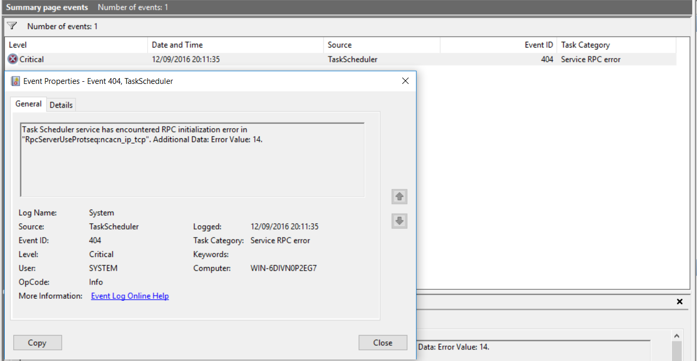

Upon searching for the error ID on the tech net website, I found out that the error was to do with the task scheduler and its inability to perform automated tasks on the pc.

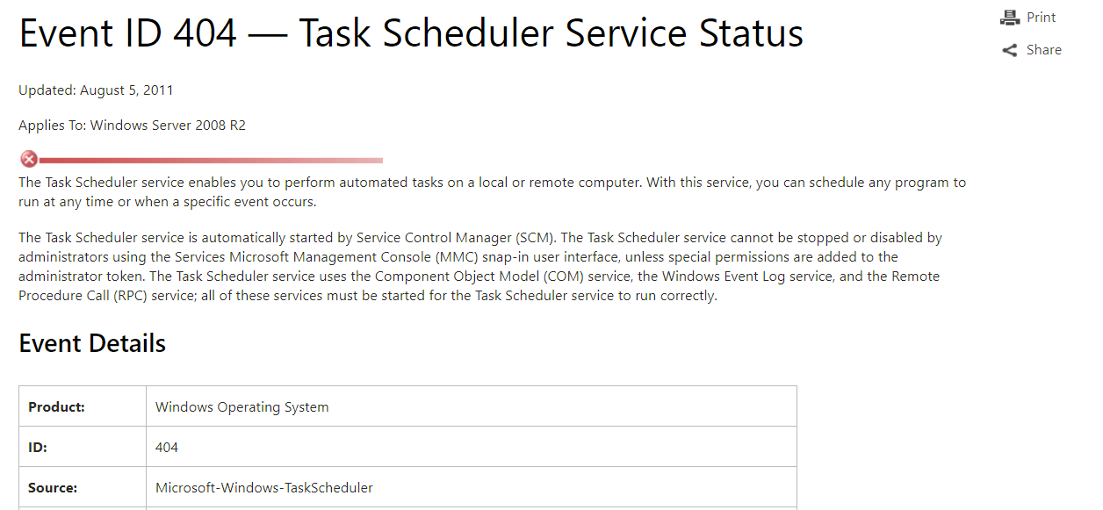

<https://technet.microsoft.com/en-us/library/dd363713(v=ws.10).aspx>

**Question 2:** Go online and research at least two different companies that manufacture hardware designed for capturing mobile phone data. Put together a short list of each one’s benefits and each one’s limitations. Chose one for your own use and explain why you chose that particular one.

**Answer**:

<https://www.cellebrite.com/en/platforms/>

Pros:

* Good hardware
* Offers round the clock, high quality support

Cons:

* More expensive.

<https://www.paraben.com/product-categories/hardware>

Pro:

* Cheaper products.

Cons:

* Small company with limited resources. Could hinder product development or product support.

I chose cellbrite as my manufacturer of choice, due to their modern approach and wide range of available hardware and excellent standard of support.